Question: There are 8 ounces in a cup4 cups in a quart and 4 pints in a gallon . Using a chain with these c...

There are 8 ounces in a cup4 cups in a quart and 4 pints in a gallon . Using a chain with these conversions, convert 6 gallons to into ounces

Expert Answer
- 
Anonymous answered this
Was this answer helpful?
0
0
261 answers
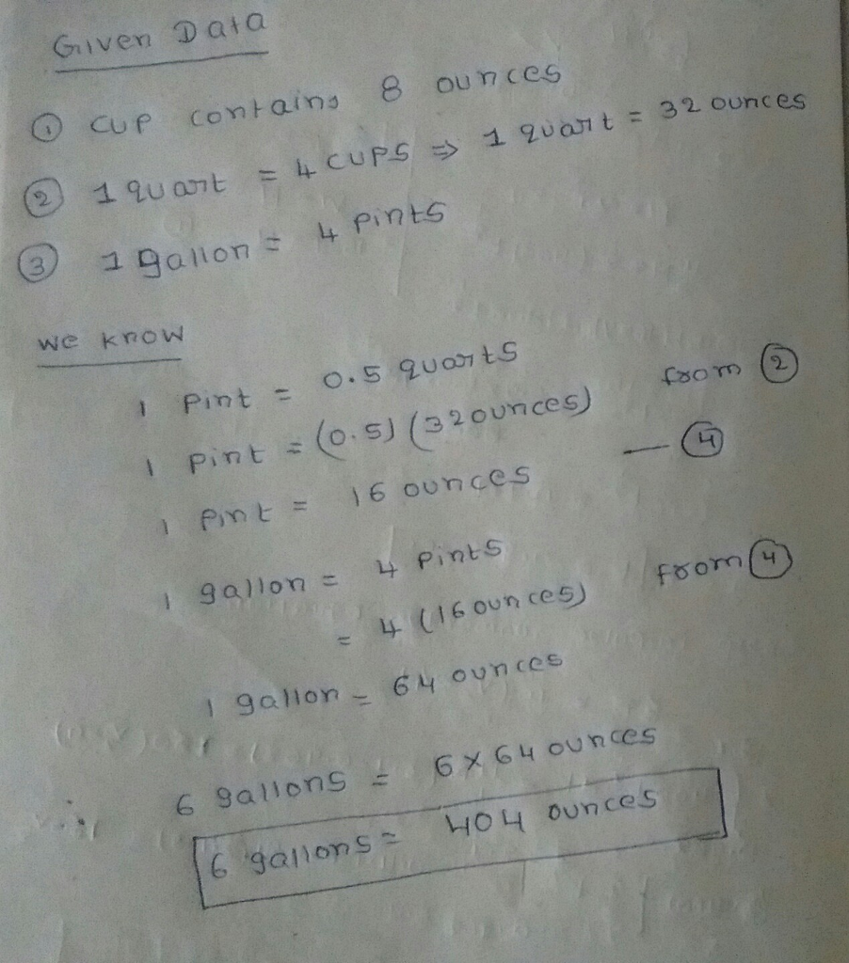
https://www.chegg.com/homework-help/questions-and-answers/8-ounces-cup4-cups-quart-4-pints-gallon--using-chain-conversions-convert-6-gallons-ounces-q25357940

